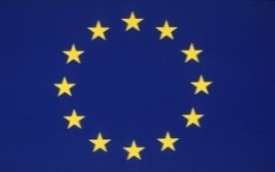
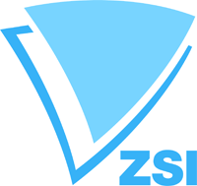

Horizon 2020 Information Day
NCP workshop

May 30, 2016

Hotel Holiday Inn Tbilisi
Tbilisi, Georgia

Welcome addresses

09:00 – 09:30 Registration of participants

09:30 - 10:00 Welcome Addresses
Ministry of Education and Science of Georgia
(Speaker to be confirmed)
Shota Rustaveli National Science Foundation (SRNSF)
Ms. Manana Mikaberidze - Deputy Director General

European Commission (Speaker to be confirmed)

EU Delegation to Georgia (tbc)

Zentrum für Soziale Innovation (ZSI)– Dr. Klaus Schuch, Scientific Director.

Session I

10:00 - 10:20 Introduction to Horizon 2020
Mr. Andrea Carignani, Head of European Neighborhood, Africa and Gulf Unit (tbc)

10:20 – 11:00 Practical information on participation:

Mr. Stephen Sadler
European Commission, DG Research & Innovation, International Cooperation Directorate, Unit C.3 - European Neighborhood, Africa and the Gulf
Ms. Teodora Balau, MSCA - cooperation with Russia, EaP and Central Assia (tbc)

11:00 – 11:30 European Research Council grants - Dr. Alice Rajewsky, Head of Sector – Humanities
European Research Council Executive Agency
ERCEA.B.5 - Social Sciences and Humanities

11:30 - 12:00 Marie Skladowska Curie Action - Ms. Teodora Balau, MSCA - cooperation with Russia, EaP and Central Assia

12:00 – 12:30 Coffee Break

Session II

12:30 – 12:50 Support of the National Contact Points
Ms. Natia Gabitashvili
H2020 National NCP Coordinator
Ministry of Education and Science of Georgia

Ms. Stella Shapoval
H2020 National NCP Coordinator
Deputy Head of International Cooperation and European Integration Department
Head of Division for International Scientific and Technical Cooperation
Ministry of Education and Science of Ukraine

12:30 – 13:10 Feedback from successful Horizon 2020 grant holders, invited experts and local grant holders

13:10 – 13:30 CeRISS – Ms. Anastasia Vlyzioti

13:30 – 14:00 Horizon 2020 projects from Georgia

14:00 – 15:30 Lunch Break

Session III Horizon 2020 National Contact Points

Societal Challenges “Secure, clean and efficient energy” and “Climate action, environment, resource efficiency and raw materials” Work Programme 2016-2017.
Calls and Funding instruments.
Practical aspects.
Horizon 2020 NCPs:
15:30 – 15:50 Ms. Natalia Shatirishvili (NCP in Energy)
15: 50 – 16:10 Mr. Givi Kochoradze (NCP in ICT)
16:10 – 16:30 Mr. Zurab Kighuradze (NCP in MSCA)
16:30 – 16:50 Ms. Maia Okujava

16:50 – 17:10 SME instrument/Innovation in SMEs/new opportunities for Georgia SMEs in H2020
Enterprise Europe Network – Georgia – Mr. David Shiolashvili

17:10 – 17:30 Georgia’s Innovation and Technology Agency – Ms. Mariam Lashkhi

17:30 – 18:00 Closing remarks

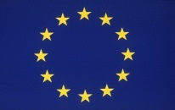
The IncoNet EaP has received funding from the European Union’s Seventh Framework Programme for research, technological development and demonstration under grant agreement no 609528.

